 | 10.1.1 Editors - Compositor - Header - Tools and Options
Table of content
Options 1
Use Nodes 1
Pin (pin icon) 1
Parent Node Tree 1
Backdrop 1
Background Image Move 2
Background Image Zoom in and out 2
Background Image Fit 2
Display channels 2
Snap 2
Node Editor Overlays 2
Wire Colors 2
Reroute Auto Labels 2
Context Path 3
Annotation 3
Previews 3
Timings 3

Options

At the right side of the header you will see the options.

Use Nodes
The Use Nodes setting is mostly a legacy setting and should always be checked for materials.

Pin (pin icon)
The pin button will keep the current material selection fixed. When a material is pinned, it will remain visible in the shader editor even when another object or material is selected elsewhere.

Parent Node Tree
Grouping nodes can simplify a node tree by allowing instancing and hiding parts of the tree. Both material and composite nodes can be grouped. This button becomes active when you work with such grouped nodes, and you are in a child group. it allows you to switch to the parent group.

Backdrop
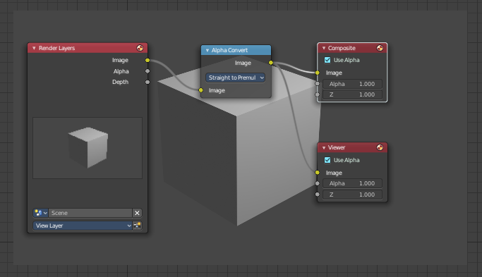
By adding a viewer node you can display the compositing result as a background in the viewport. Here you can activate it, and adjust the look. It also contains controls to adjust the zoom and position of the backdrop image.

Background Image Move
Move the background image. A click confirms. Watch the hotkey.

Background Image Zoom in and out
Zoom in and out the Background image.

Background Image Fit
Fits the background image into the view.

Display channels
What channels to display in the backdrop.

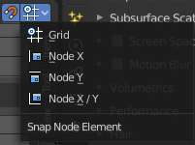
Snap
Activates snapping. When the tool is activated, then you will also reveal the snap settings where you can choose different snap methods.

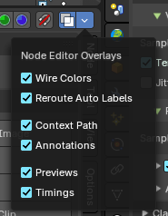
Node Editor Overlays
Activates the node editor overlays. When the tool is activated, then you will also overlays settings in the editor. The drop down arrow to the right shows different overlay types.

Show Overlays
Show or hide the overlays.

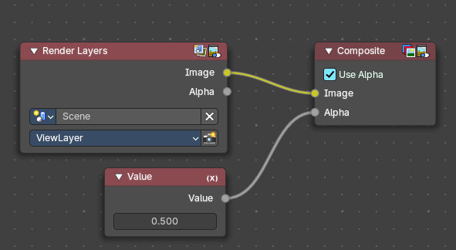
Wire Colors
Color node links based on their connected sockets.
Example: The color Image socket is yellow that makes a yellow line, and the Value socket is grey that makes a grey line.

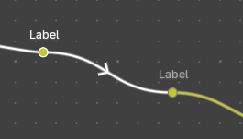
Reroute Auto Labels
Label reroute nodes based on the label of connected reroute nodes.
Example: The first reroute label to the right has concurring reroute labels down the line. If you toggle this off, the concurring reroute labels down the line won’t contain labels.

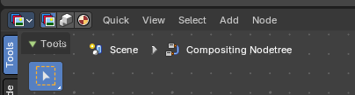
Context Path
Display breadcrumbs for the editor’s context.

Annotation
Shows annotations for this editor view that have been drawn by the annotation tool.

Previews
Shows each nodes preview thumbnails if the node has previews toggled on.

Timings
Shows a timing box above each node to indicate the evaluation time of it.. This option is only available for compositing and geometry nodes.

